Class 13: Transcriptomics and the analysis of RNA-Seq data

Brittney Hayes

2024-02-24

## Import countData and ColData

# Complete the missing code  
counts <- read.csv("airway_scaledcounts.csv", row.names=1)  
metadata <- read.csv("airway_metadata.csv")

Taking a look at each

head(counts)

## SRR1039508 SRR1039509 SRR1039512 SRR1039513 SRR1039516  
## ENSG00000000003 723 486 904 445 1170  
## ENSG00000000005 0 0 0 0 0  
## ENSG00000000419 467 523 616 371 582  
## ENSG00000000457 347 258 364 237 318  
## ENSG00000000460 96 81 73 66 118  
## ENSG00000000938 0 0 1 0 2  
## SRR1039517 SRR1039520 SRR1039521  
## ENSG00000000003 1097 806 604  
## ENSG00000000005 0 0 0  
## ENSG00000000419 781 417 509  
## ENSG00000000457 447 330 324  
## ENSG00000000460 94 102 74  
## ENSG00000000938 0 0 0

head(metadata)

## id dex celltype geo_id  
## 1 SRR1039508 control N61311 GSM1275862  
## 2 SRR1039509 treated N61311 GSM1275863  
## 3 SRR1039512 control N052611 GSM1275866  
## 4 SRR1039513 treated N052611 GSM1275867  
## 5 SRR1039516 control N080611 GSM1275870  
## 6 SRR1039517 treated N080611 GSM1275871

Sanity check on correspondance of counts on metadata

all (metadata$id == colnames(counts))

## [1] TRUE

Q1. How many genes are in this dataset?

There are 38694 genes in this dataset.

Q2. How many ‘control’ cell lines do we have?

There are 4 control cell lines in this dataset.

## Toy differential gene expression

Extract and summarize the control samples

To find out where the control samples are we need the metadata

control <- metadata[metadata[,"dex"]=="control",]  
control.counts <- counts[ ,control$id]  
control.mean <- rowMeans( control.counts )  
head(control.mean)

## ENSG00000000003 ENSG00000000005 ENSG00000000419 ENSG00000000457 ENSG00000000460   
## 900.75 0.00 520.50 339.75 97.25   
## ENSG00000000938   
## 0.75

# Q3. How would you make the above code in either approach more robust? Is there a function that could help here?

Use the rowMeans() function.

# Q4. Follow the same procedure for the treated samples (i.e. calculate the mean per gene across drug treated samples and assign to a labeled vector called treated.mean)

treated <- metadata[metadata[,"dex"]=="treated",]  
treated.counts <- counts[ ,treated$id]  
treated.mean <- rowMeans( treated.counts )  
head(treated.mean)

## ENSG00000000003 ENSG00000000005 ENSG00000000419 ENSG00000000457 ENSG00000000460   
## 658.00 0.00 546.00 316.50 78.75   
## ENSG00000000938   
## 0.00

# We will combine our meancount data for bookkeeping purposes  
meancounts <- data.frame(control.mean, treated.mean)  
colSums(meancounts)

## control.mean treated.mean   
## 23005324 22196524

# Q5 (a). Create a scatter plot showing the mean of the treated samples against the mean of the control samples. Your plot should look something like the following.

plot(meancounts[,1],meancounts[,2], xlab="Control", ylab="Treated")

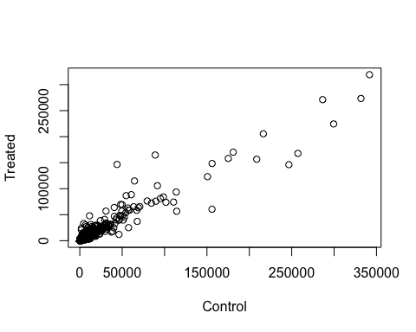

# Q5 (b).You could also use the ggplot2 package to make this figure producing the plot below. What geom_?() function would you use for this plot?

We would use the geom_point() function.

library(ggplot2)  
  
ggplot(meancounts) +  
 aes(control.mean, treated.mean) +  
 geom_point()

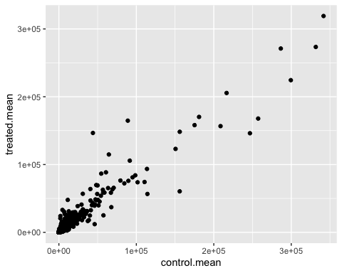

# Q6. Try plotting both axes on a log scale. What is the argument to plot() that allows you to do this?

log=“xy” allows us to do this.

plot(meancounts[,1], meancounts[,2], log="xy",  
 xlab="log control counts",  
 ylab="log of treated counts")

## Warning in xy.coords(x, y, xlabel, ylabel, log): 15032 x values <= 0 omitted  
## from logarithmic plot

## Warning in xy.coords(x, y, xlabel, ylabel, log): 15281 y values <= 0 omitted  
## from logarithmic plot

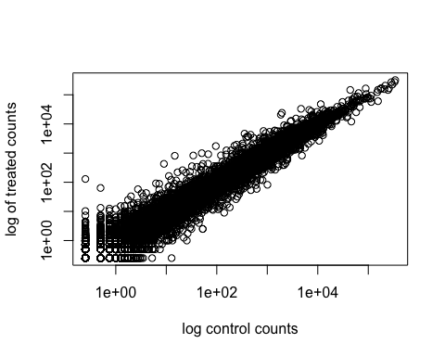

Adding a log2 fold change column to our results

meancounts$log2fc <- log2(meancounts$treated.mean / meancounts$control.mean)

head(meancounts)

## control.mean treated.mean log2fc  
## ENSG00000000003 900.75 658.00 -0.45303916  
## ENSG00000000005 0.00 0.00 NaN  
## ENSG00000000419 520.50 546.00 0.06900279  
## ENSG00000000457 339.75 316.50 -0.10226805  
## ENSG00000000460 97.25 78.75 -0.30441833  
## ENSG00000000938 0.75 0.00 -Inf

There are a lot of genes with zero expression. Let’s filter our data to remove these genes.

zero.vals <- which(meancounts[,1:2]==0, arr.ind=TRUE)  
  
to.rm <- unique(zero.vals[,1])  
mycounts <- meancounts[-to.rm,]  
head(mycounts)

## control.mean treated.mean log2fc  
## ENSG00000000003 900.75 658.00 -0.45303916  
## ENSG00000000419 520.50 546.00 0.06900279  
## ENSG00000000457 339.75 316.50 -0.10226805  
## ENSG00000000460 97.25 78.75 -0.30441833  
## ENSG00000000971 5219.00 6687.50 0.35769358  
## ENSG00000001036 2327.00 1785.75 -0.38194109

How many genes are remaining?

nrow(mycounts)

## [1] 21817

# Q7. What is the purpose of the arr.ind argument in the which() function call above? Why would we then take the first column of the output and need to call the unique() function?

The arr.ind=TRUE argument will clause which() to return the row and column indices (i.e. positions) where there are TRUE values. This will tell us which genes (rows) and samples (columns) have zero counts. We are going to ignore any genes that have zero counts in any sample so we just focus on the row answer. Calling unique() will ensure we don’t count any row twice if it has zero entries in both samples.

Filter the dataset both ways to see how many genes are up or down-regulated.

up.ind <- mycounts$log2fc > 2  
down.ind <- mycounts$log2fc < (-2)

# Q8. Using the up.ind vector above can you determine how many up regulated genes we have at the greater than 2 fc level?

sum(up.ind)

## [1] 250

There are 250 up regulated genes.

# Q9. Using the down.ind vector above can you determine how many down regulated genes we have at the greater than 2 fc level?

sum(down.ind)

## [1] 367

There are 367 down regulated genes.

# Q10. Do you trust these results? Why or why not?

Fold change can be large without being statistically significant. We have not done anything yet to determine whether the differences we are seeing are significant. These results in their current form cannot be trusted.

## Setting up for DESeq

library(DESeq2)

## Loading required package: S4Vectors

## Loading required package: stats4

## Loading required package: BiocGenerics

##   
## Attaching package: 'BiocGenerics'

## The following objects are masked from 'package:stats':  
##   
## IQR, mad, sd, var, xtabs

## The following objects are masked from 'package:base':  
##   
## anyDuplicated, aperm, append, as.data.frame, basename, cbind,  
## colnames, dirname, do.call, duplicated, eval, evalq, Filter, Find,  
## get, grep, grepl, intersect, is.unsorted, lapply, Map, mapply,  
## match, mget, order, paste, pmax, pmax.int, pmin, pmin.int,  
## Position, rank, rbind, Reduce, rownames, sapply, setdiff, sort,  
## table, tapply, union, unique, unsplit, which.max, which.min

##   
## Attaching package: 'S4Vectors'

## The following object is masked from 'package:utils':  
##   
## findMatches

## The following objects are masked from 'package:base':  
##   
## expand.grid, I, unname

## Loading required package: IRanges

## Loading required package: GenomicRanges

## Loading required package: GenomeInfoDb

## Loading required package: SummarizedExperiment

## Loading required package: MatrixGenerics

## Loading required package: matrixStats

##   
## Attaching package: 'MatrixGenerics'

## The following objects are masked from 'package:matrixStats':  
##   
## colAlls, colAnyNAs, colAnys, colAvgsPerRowSet, colCollapse,  
## colCounts, colCummaxs, colCummins, colCumprods, colCumsums,  
## colDiffs, colIQRDiffs, colIQRs, colLogSumExps, colMadDiffs,  
## colMads, colMaxs, colMeans2, colMedians, colMins, colOrderStats,  
## colProds, colQuantiles, colRanges, colRanks, colSdDiffs, colSds,  
## colSums2, colTabulates, colVarDiffs, colVars, colWeightedMads,  
## colWeightedMeans, colWeightedMedians, colWeightedSds,  
## colWeightedVars, rowAlls, rowAnyNAs, rowAnys, rowAvgsPerColSet,  
## rowCollapse, rowCounts, rowCummaxs, rowCummins, rowCumprods,  
## rowCumsums, rowDiffs, rowIQRDiffs, rowIQRs, rowLogSumExps,  
## rowMadDiffs, rowMads, rowMaxs, rowMeans2, rowMedians, rowMins,  
## rowOrderStats, rowProds, rowQuantiles, rowRanges, rowRanks,  
## rowSdDiffs, rowSds, rowSums2, rowTabulates, rowVarDiffs, rowVars,  
## rowWeightedMads, rowWeightedMeans, rowWeightedMedians,  
## rowWeightedSds, rowWeightedVars

## Loading required package: Biobase

## Welcome to Bioconductor  
##   
## Vignettes contain introductory material; view with  
## 'browseVignettes()'. To cite Bioconductor, see  
## 'citation("Biobase")', and for packages 'citation("pkgname")'.

##   
## Attaching package: 'Biobase'

## The following object is masked from 'package:MatrixGenerics':  
##   
## rowMedians

## The following objects are masked from 'package:matrixStats':  
##   
## anyMissing, rowMedians

citation("DESeq2")

## To cite package 'DESeq2' in publications use:  
##   
## Love, M.I., Huber, W., Anders, S. Moderated estimation of fold change  
## and dispersion for RNA-seq data with DESeq2 Genome Biology 15(12):550  
## (2014)  
##   
## A BibTeX entry for LaTeX users is  
##   
## @Article{,  
## title = {Moderated estimation of fold change and dispersion for RNA-seq data with DESeq2},  
## author = {Michael I. Love and Wolfgang Huber and Simon Anders},  
## year = {2014},  
## journal = {Genome Biology},  
## doi = {10.1186/s13059-014-0550-8},  
## volume = {15},  
## issue = {12},  
## pages = {550},  
## }

dds <- DESeqDataSetFromMatrix(countData=counts,   
 colData=metadata,   
 design=~dex)

## converting counts to integer mode

## Warning in DESeqDataSet(se, design = design, ignoreRank): some variables in  
## design formula are characters, converting to factors

dds

## class: DESeqDataSet   
## dim: 38694 8   
## metadata(1): version  
## assays(1): counts  
## rownames(38694): ENSG00000000003 ENSG00000000005 ... ENSG00000283120  
## ENSG00000283123  
## rowData names(0):  
## colnames(8): SRR1039508 SRR1039509 ... SRR1039520 SRR1039521  
## colData names(4): id dex celltype geo_id

## Principal component analysis

Calling vst() to apply a variance stabilizing transformation and then plotPCA() to calculate our PCs and plot the results.

vsd <- vst(dds, blind = FALSE)  
plotPCA(vsd, intgroup = c("dex"))

## using ntop=500 top features by variance

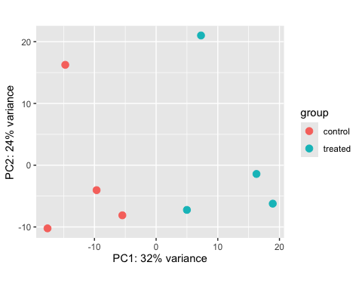

Build the PCA plot from scratch using the ggplot2 package

pcaData <- plotPCA(vsd, intgroup=c("dex"), returnData=TRUE)

## using ntop=500 top features by variance

head(pcaData)

## PC1 PC2 group dex name  
## SRR1039508 -17.607922 -10.225252 control control SRR1039508  
## SRR1039509 4.996738 -7.238117 treated treated SRR1039509  
## SRR1039512 -5.474456 -8.113993 control control SRR1039512  
## SRR1039513 18.912974 -6.226041 treated treated SRR1039513  
## SRR1039516 -14.729173 16.252000 control control SRR1039516  
## SRR1039517 7.279863 21.008034 treated treated SRR1039517

# Calculate percent variance per PC for the plot axis labels  
percentVar <- round(100 * attr(pcaData, "percentVar"))

ggplot(pcaData) +  
 aes(x = PC1, y = PC2, color = dex) +  
 geom_point(size =3) +  
 xlab(paste0("PC1: ", percentVar[1], "% variance")) +  
 ylab(paste0("PC2: ", percentVar[2], "% variance")) +  
 coord_fixed() +  
 theme_bw()

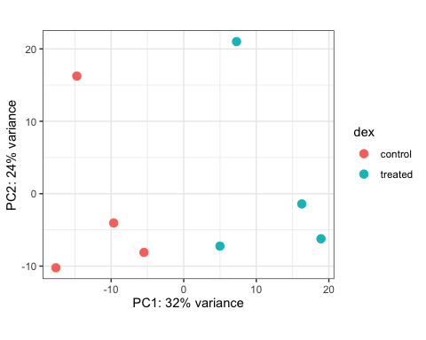

## DESeq analysis

dds <- DESeq(dds)

## estimating size factors

## estimating dispersions

## gene-wise dispersion estimates

## mean-dispersion relationship

## final dispersion estimates

## fitting model and testing

res <- results(dds)  
res

## log2 fold change (MLE): dex treated vs control   
## Wald test p-value: dex treated vs control   
## DataFrame with 38694 rows and 6 columns  
## baseMean log2FoldChange lfcSE stat pvalue  
## <numeric> <numeric> <numeric> <numeric> <numeric>  
## ENSG00000000003 747.1942 -0.3507030 0.168246 -2.084470 0.0371175  
## ENSG00000000005 0.0000 NA NA NA NA  
## ENSG00000000419 520.1342 0.2061078 0.101059 2.039475 0.0414026  
## ENSG00000000457 322.6648 0.0245269 0.145145 0.168982 0.8658106  
## ENSG00000000460 87.6826 -0.1471420 0.257007 -0.572521 0.5669691  
## ... ... ... ... ... ...  
## ENSG00000283115 0.000000 NA NA NA NA  
## ENSG00000283116 0.000000 NA NA NA NA  
## ENSG00000283119 0.000000 NA NA NA NA  
## ENSG00000283120 0.974916 -0.668258 1.69456 -0.394354 0.693319  
## ENSG00000283123 0.000000 NA NA NA NA  
## padj  
## <numeric>  
## ENSG00000000003 0.163035  
## ENSG00000000005 NA  
## ENSG00000000419 0.176032  
## ENSG00000000457 0.961694  
## ENSG00000000460 0.815849  
## ... ...  
## ENSG00000283115 NA  
## ENSG00000283116 NA  
## ENSG00000283119 NA  
## ENSG00000283120 NA  
## ENSG00000283123 NA

#summarize some basic tallies using the summary function  
summary(res)

##   
## out of 25258 with nonzero total read count  
## adjusted p-value < 0.1  
## LFC > 0 (up) : 1563, 6.2%  
## LFC < 0 (down) : 1188, 4.7%  
## outliers [1] : 142, 0.56%  
## low counts [2] : 9971, 39%  
## (mean count < 10)  
## [1] see 'cooksCutoff' argument of ?results  
## [2] see 'independentFiltering' argument of ?results

res05 <- results(dds, alpha=0.05)  
summary(res05)

##   
## out of 25258 with nonzero total read count  
## adjusted p-value < 0.05  
## LFC > 0 (up) : 1236, 4.9%  
## LFC < 0 (down) : 933, 3.7%  
## outliers [1] : 142, 0.56%  
## low counts [2] : 9033, 36%  
## (mean count < 6)  
## [1] see 'cooksCutoff' argument of ?results  
## [2] see 'independentFiltering' argument of ?results

## Adding annotation data

library("AnnotationDbi")  
library("org.Hs.eg.db")

##

columns(org.Hs.eg.db)

## [1] "ACCNUM" "ALIAS" "ENSEMBL" "ENSEMBLPROT" "ENSEMBLTRANS"  
## [6] "ENTREZID" "ENZYME" "EVIDENCE" "EVIDENCEALL" "GENENAME"   
## [11] "GENETYPE" "GO" "GOALL" "IPI" "MAP"   
## [16] "OMIM" "ONTOLOGY" "ONTOLOGYALL" "PATH" "PFAM"   
## [21] "PMID" "PROSITE" "REFSEQ" "SYMBOL" "UCSCKG"   
## [26] "UNIPROT"

#use the mapIds() function to add individual columns to our results table  
res$symbol <- mapIds(org.Hs.eg.db,  
 keys=row.names(res),  
 keytype="ENSEMBL",  
 column="SYMBOL",   
 multiVals="first")

## 'select()' returned 1:many mapping between keys and columns

head(res)

## log2 fold change (MLE): dex treated vs control   
## Wald test p-value: dex treated vs control   
## DataFrame with 6 rows and 7 columns  
## baseMean log2FoldChange lfcSE stat pvalue  
## <numeric> <numeric> <numeric> <numeric> <numeric>  
## ENSG00000000003 747.194195 -0.3507030 0.168246 -2.084470 0.0371175  
## ENSG00000000005 0.000000 NA NA NA NA  
## ENSG00000000419 520.134160 0.2061078 0.101059 2.039475 0.0414026  
## ENSG00000000457 322.664844 0.0245269 0.145145 0.168982 0.8658106  
## ENSG00000000460 87.682625 -0.1471420 0.257007 -0.572521 0.5669691  
## ENSG00000000938 0.319167 -1.7322890 3.493601 -0.495846 0.6200029  
## padj symbol  
## <numeric> <character>  
## ENSG00000000003 0.163035 TSPAN6  
## ENSG00000000005 NA TNMD  
## ENSG00000000419 0.176032 DPM1  
## ENSG00000000457 0.961694 SCYL3  
## ENSG00000000460 0.815849 FIRRM  
## ENSG00000000938 NA FGR

# Q11. Run the mapIds() function two more times to add the Entrez ID and UniProt accession and GENENAME as new columns called res $entrez,res$ uniprot and res$genename.

res$entrez <- mapIds(org.Hs.eg.db,  
 keys=row.names(res),  
 column="ENTREZID",  
 keytype="ENSEMBL",  
 multiVals="first")

## 'select()' returned 1:many mapping between keys and columns

res$uniprot <- mapIds(org.Hs.eg.db,  
 keys=row.names(res),  
 column="UNIPROT",  
 keytype="ENSEMBL",  
 multiVals="first")

## 'select()' returned 1:many mapping between keys and columns

res$genename <- mapIds(org.Hs.eg.db,  
 keys=row.names(res),  
 column="GENENAME",  
 keytype="ENSEMBL",  
 multiVals="first")

## 'select()' returned 1:many mapping between keys and columns

head(res)

## log2 fold change (MLE): dex treated vs control   
## Wald test p-value: dex treated vs control   
## DataFrame with 6 rows and 10 columns  
## baseMean log2FoldChange lfcSE stat pvalue  
## <numeric> <numeric> <numeric> <numeric> <numeric>  
## ENSG00000000003 747.194195 -0.3507030 0.168246 -2.084470 0.0371175  
## ENSG00000000005 0.000000 NA NA NA NA  
## ENSG00000000419 520.134160 0.2061078 0.101059 2.039475 0.0414026  
## ENSG00000000457 322.664844 0.0245269 0.145145 0.168982 0.8658106  
## ENSG00000000460 87.682625 -0.1471420 0.257007 -0.572521 0.5669691  
## ENSG00000000938 0.319167 -1.7322890 3.493601 -0.495846 0.6200029  
## padj symbol entrez uniprot  
## <numeric> <character> <character> <character>  
## ENSG00000000003 0.163035 TSPAN6 7105 A0A024RCI0  
## ENSG00000000005 NA TNMD 64102 Q9H2S6  
## ENSG00000000419 0.176032 DPM1 8813 O60762  
## ENSG00000000457 0.961694 SCYL3 57147 Q8IZE3  
## ENSG00000000460 0.815849 FIRRM 55732 A0A024R922  
## ENSG00000000938 NA FGR 2268 P09769  
## genename  
## <character>  
## ENSG00000000003 tetraspanin 6  
## ENSG00000000005 tenomodulin  
## ENSG00000000419 dolichyl-phosphate m..  
## ENSG00000000457 SCY1 like pseudokina..  
## ENSG00000000460 FIGNL1 interacting r..  
## ENSG00000000938 FGR proto-oncogene, ..

arrange and view the results by the adjusted p-value

ord <- order( res$padj )  
#View(res[ord,])  
head(res[ord,])

## log2 fold change (MLE): dex treated vs control   
## Wald test p-value: dex treated vs control   
## DataFrame with 6 rows and 10 columns  
## baseMean log2FoldChange lfcSE stat pvalue  
## <numeric> <numeric> <numeric> <numeric> <numeric>  
## ENSG00000152583 954.771 4.36836 0.2371268 18.4220 8.74490e-76  
## ENSG00000179094 743.253 2.86389 0.1755693 16.3120 8.10784e-60  
## ENSG00000116584 2277.913 -1.03470 0.0650984 -15.8944 6.92855e-57  
## ENSG00000189221 2383.754 3.34154 0.2124058 15.7319 9.14433e-56  
## ENSG00000120129 3440.704 2.96521 0.2036951 14.5571 5.26424e-48  
## ENSG00000148175 13493.920 1.42717 0.1003890 14.2164 7.25128e-46  
## padj symbol entrez uniprot  
## <numeric> <character> <character> <character>  
## ENSG00000152583 1.32441e-71 SPARCL1 8404 A0A024RDE1  
## ENSG00000179094 6.13966e-56 PER1 5187 O15534  
## ENSG00000116584 3.49776e-53 ARHGEF2 9181 Q92974  
## ENSG00000189221 3.46227e-52 MAOA 4128 P21397  
## ENSG00000120129 1.59454e-44 DUSP1 1843 B4DU40  
## ENSG00000148175 1.83034e-42 STOM 2040 F8VSL7  
## genename  
## <character>  
## ENSG00000152583 SPARC like 1  
## ENSG00000179094 period circadian reg..  
## ENSG00000116584 Rho/Rac guanine nucl..  
## ENSG00000189221 monoamine oxidase A  
## ENSG00000120129 dual specificity pho..  
## ENSG00000148175 stomatin

write.csv(res[ord,], "deseq_results.csv")

## Data Visualization

Volcano plot

plot( res$log2FoldChange, -log(res$padj),   
 xlab="Log2(FoldChange)",  
 ylab="-Log(P-value)")

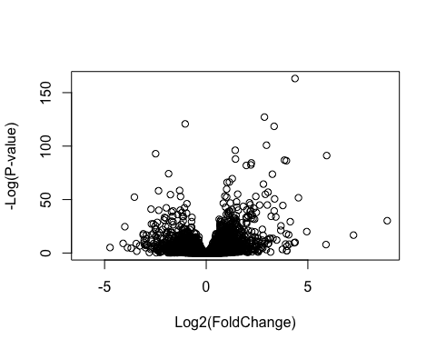

plot( res$log2FoldChange, -log(res$padj),   
 ylab="-Log(P-value)", xlab="Log2(FoldChange)")  
  
# Add some cut-off lines  
abline(v=c(-2,2), col="darkgray", lty=2)  
abline(h=-log(0.05), col="darkgray", lty=2)

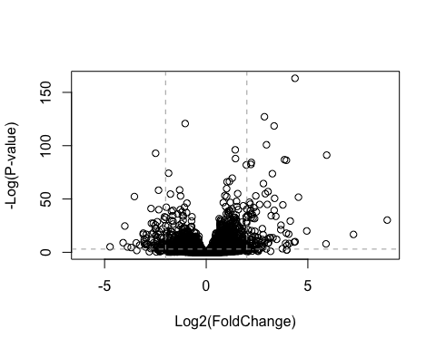

# Setup our custom point color vector   
mycols <- rep("gray", nrow(res))  
mycols[ abs(res$log2FoldChange) > 2 ] <- "red"   
  
inds <- (res$padj < 0.01) & (abs(res$log2FoldChange) > 2 )  
mycols[ inds ] <- "blue"  
  
# Volcano plot with custom colors   
plot( res$log2FoldChange, -log(res$padj),   
 col=mycols, ylab="-Log(P-value)", xlab="Log2(FoldChange)" )  
  
# Cut-off lines  
abline(v=c(-2,2), col="gray", lty=2)  
abline(h=-log(0.1), col="gray", lty=2)

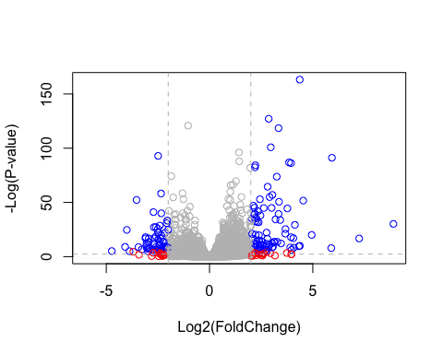

library(EnhancedVolcano)

## Loading required package: ggrepel

x <- as.data.frame(res)  
  
EnhancedVolcano(x,  
 lab = x$symbol,  
 x = 'log2FoldChange',  
 y = 'pvalue')

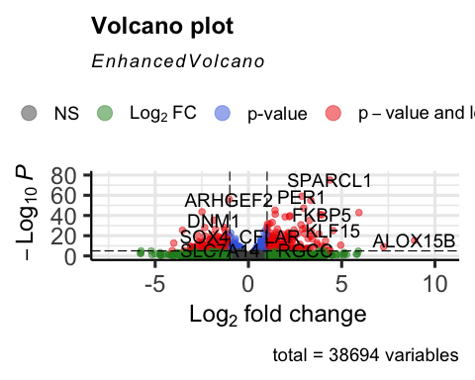

## Pathway analysis

library(pathview)

## ##############################################################################  
## Pathview is an open source software package distributed under GNU General  
## Public License version 3 (GPLv3). Details of GPLv3 is available at  
## http://www.gnu.org/licenses/gpl-3.0.html. Particullary, users are required to  
## formally cite the original Pathview paper (not just mention it) in publications  
## or products. For details, do citation("pathview") within R.  
##   
## The pathview downloads and uses KEGG data. Non-academic uses may require a KEGG  
## license agreement (details at http://www.kegg.jp/kegg/legal.html).  
## ##############################################################################

library(gage)

##

library(gageData)  
  
data(kegg.sets.hs)  
  
# Examine the first 2 pathways in this kegg set for humans  
head(kegg.sets.hs, 2)

## $`hsa00232 Caffeine metabolism`  
## [1] "10" "1544" "1548" "1549" "1553" "7498" "9"   
##   
## $`hsa00983 Drug metabolism - other enzymes`  
## [1] "10" "1066" "10720" "10941" "151531" "1548" "1549" "1551"   
## [9] "1553" "1576" "1577" "1806" "1807" "1890" "221223" "2990"   
## [17] "3251" "3614" "3615" "3704" "51733" "54490" "54575" "54576"   
## [25] "54577" "54578" "54579" "54600" "54657" "54658" "54659" "54963"   
## [33] "574537" "64816" "7083" "7084" "7172" "7363" "7364" "7365"   
## [41] "7366" "7367" "7371" "7372" "7378" "7498" "79799" "83549"   
## [49] "8824" "8833" "9" "978"

foldchanges = res$log2FoldChange  
names(foldchanges) = res$entrez  
head(foldchanges)

## 7105 64102 8813 57147 55732 2268   
## -0.35070302 NA 0.20610777 0.02452695 -0.14714205 -1.73228897

# Get the results  
keggres = gage(foldchanges, gsets=kegg.sets.hs)

attributes(keggres)

## $names  
## [1] "greater" "less" "stats"

# Look at the first three down (less) pathways  
head(keggres$less, 3)

## p.geomean stat.mean p.val  
## hsa05332 Graft-versus-host disease 0.0004250461 -3.473346 0.0004250461  
## hsa04940 Type I diabetes mellitus 0.0017820293 -3.002352 0.0017820293  
## hsa05310 Asthma 0.0020045888 -3.009050 0.0020045888  
## q.val set.size exp1  
## hsa05332 Graft-versus-host disease 0.09053483 40 0.0004250461  
## hsa04940 Type I diabetes mellitus 0.14232581 42 0.0017820293  
## hsa05310 Asthma 0.14232581 29 0.0020045888

pathview(gene.data=foldchanges, pathway.id="hsa05310")

## 'select()' returned 1:1 mapping between keys and columns

## Info: Working in directory /Users/brittneyhannah/Desktop/Class 13

## Info: Writing image file hsa05310.pathview.png

# A different PDF based output of the same data  
pathview(gene.data=foldchanges, pathway.id="hsa05310", kegg.native=FALSE)

## 'select()' returned 1:1 mapping between keys and columns

## Info: Working in directory /Users/brittneyhannah/Desktop/Class 13

## Info: Writing image file hsa05310.pathview.pdf

# Q12. Can you do the same procedure as above to plot the pathview figures for the top 2 down-reguled pathways?

Yes, we can use DESeq and make volcano plots.

## PLotting counts for genes of interest

i <- grep("CRISPLD2", res$symbol)  
res[i,]

## log2 fold change (MLE): dex treated vs control   
## Wald test p-value: dex treated vs control   
## DataFrame with 1 row and 10 columns  
## baseMean log2FoldChange lfcSE stat pvalue  
## <numeric> <numeric> <numeric> <numeric> <numeric>  
## ENSG00000103196 3096.16 2.62603 0.267444 9.81899 9.32747e-23  
## padj symbol entrez uniprot  
## <numeric> <character> <character> <character>  
## ENSG00000103196 3.36344e-20 CRISPLD2 83716 A0A140VK80  
## genename  
## <character>  
## ENSG00000103196 cysteine rich secret..

rownames(res[i,])

## [1] "ENSG00000103196"

plotCounts(dds, gene="ENSG00000103196", intgroup="dex")

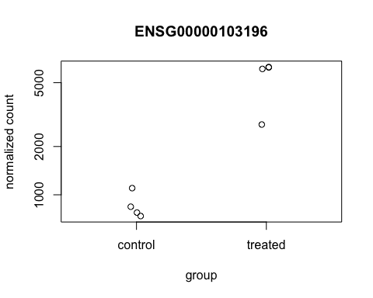

# Return the data  
d <- plotCounts(dds, gene="ENSG00000103196", intgroup="dex", returnData=TRUE)  
head(d)

## count dex  
## SRR1039508 774.5002 control  
## SRR1039509 6258.7915 treated  
## SRR1039512 1100.2741 control  
## SRR1039513 6093.0324 treated  
## SRR1039516 736.9483 control  
## SRR1039517 2742.1908 treated

boxplot(count ~ dex , data=d)

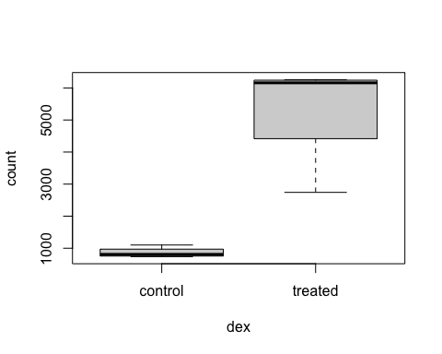

library(ggplot2)  
ggplot(d, aes(dex, count, fill=dex)) +   
 geom_boxplot() +   
 scale_y_log10() +   
 ggtitle("CRISPLD2")

